 |  |  |  |  | “SEAMANSHIP TRAINING MODULE”  Romanian Naval Academy -CONSTANTA/ROMANIA  24th – 28th of June 2024  Application form |  | 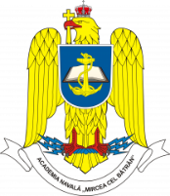
Male | Female |  | Rank | Family name |  | First name

Date of birth | Nationality | Passport number | Passport expiration date

Branch of Service (if available) | Sending institution

Phone no. | Mobile phone number | e-mail address
Arrival at  Bucharest/Otopeni Airport | Need transfer? | Arrival date/ETA | Flight no.
Departure from  Bucharest/Otopeni Airport | Need transfer? | Arrival date/ETD | Flight no.

Special dietary or food restrictions | If yes, please specify details:

Additional remarks (need for special equipment, special travel arrangements, ….)

Point of contact (POC) of sending institute
Male | Female | Rank | Family name | First name
POC’s phone number | POC’s e-mail address

Remarks:
- Please fill in the yellow fields only.
- Fill in 1 form for each person.
- The flight details will be extended once available.

Upon completion submit the final form to RNA PoC: Lt.Cdr Marius Cucu, international@anmb.ro

